- Wireless Standard & Configuration

Q1. Set up a basic wireless network using a home Wi-Fi router and connect your laptop or phone to it, then note down the SSID and the default channel used by the router?

Answer
- I created a wireless network using a WRT300N wireless router, Laptop0, and Smartphone0 in Cisco Packet Tracer.
- I configured the SSID as HOME-WIFI.
- The default wireless channel was 1 (2.412 GHz).
- I connected both Laptop0 and Smartphone0 to the wireless network.
- Both devices successfully received IP addresses through DHCP:
  - Laptop0: 192.168.0.101
  - Smartphone0: 192.168.0.100
- Result: Both devices connected successfully to the wireless network.
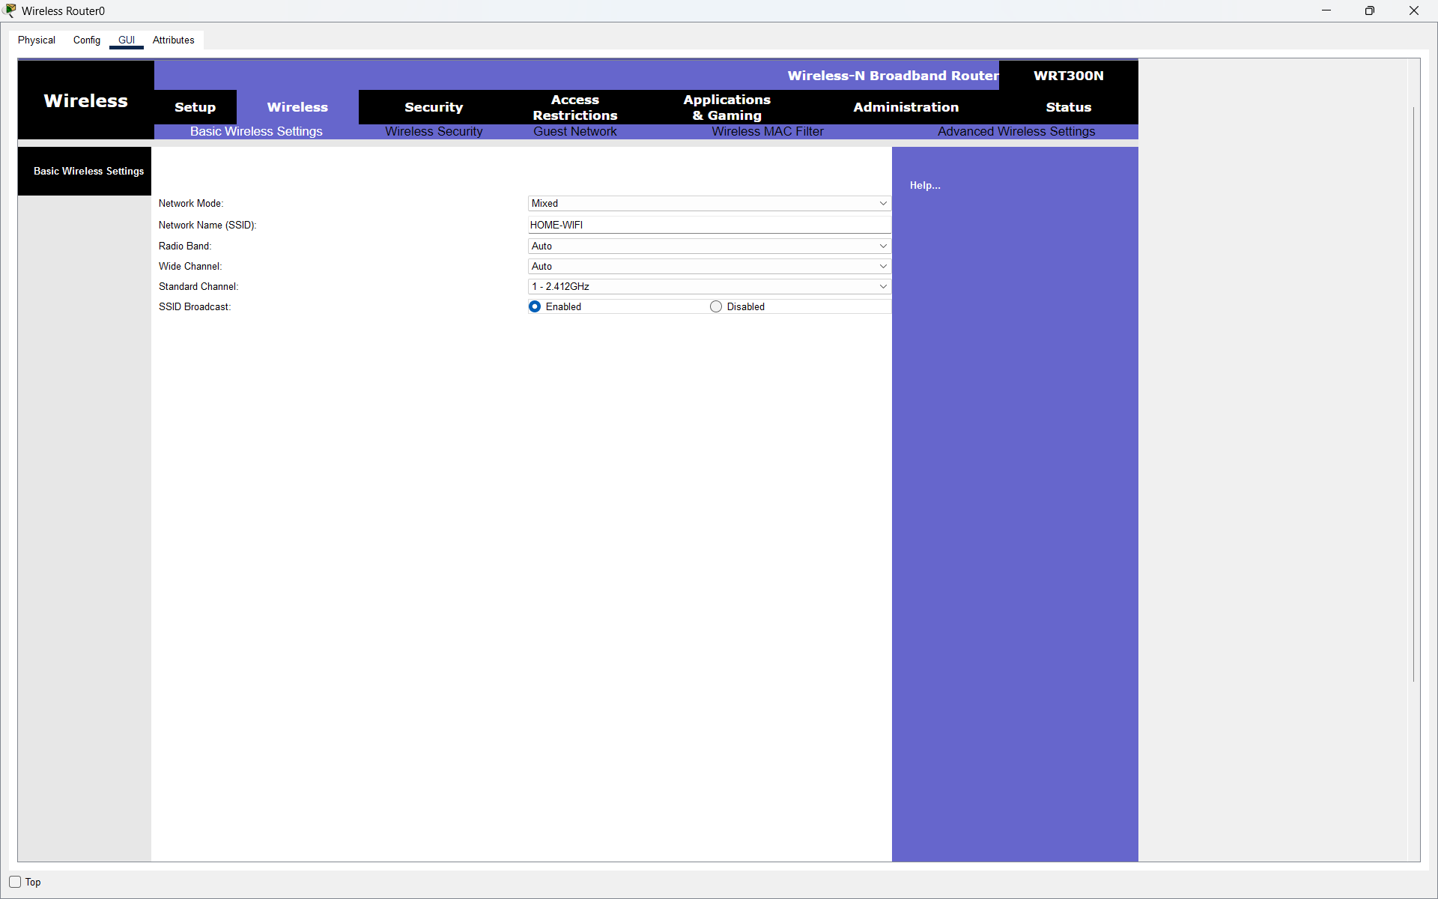
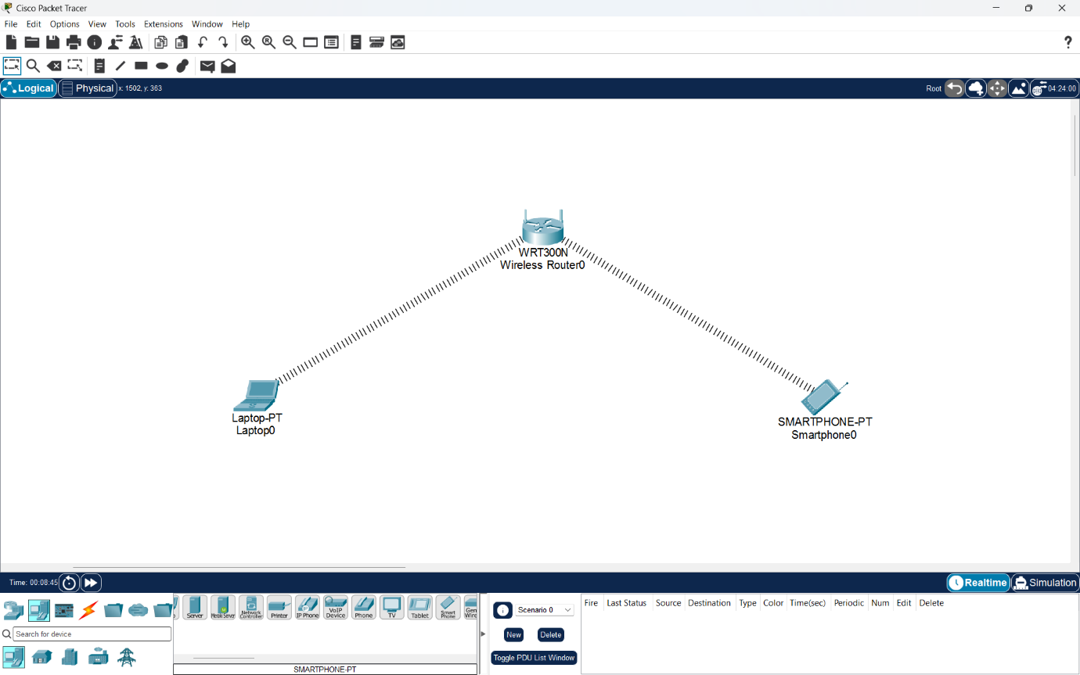

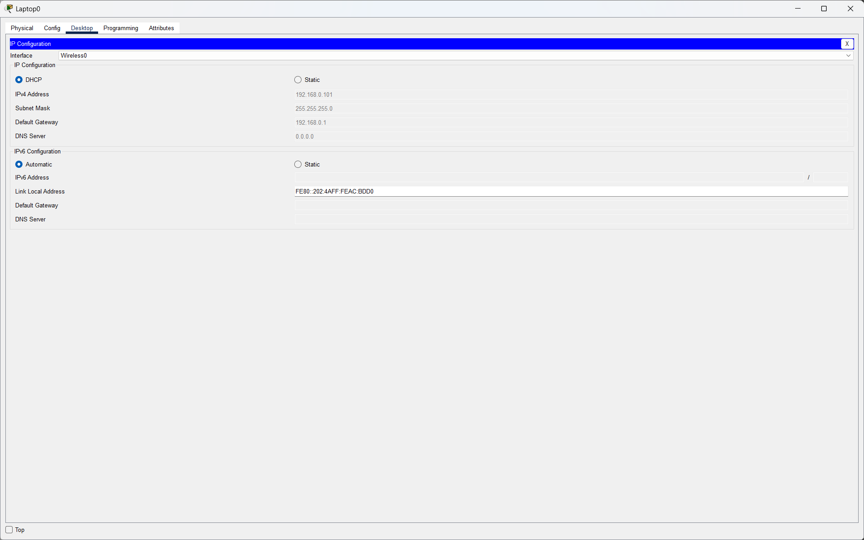
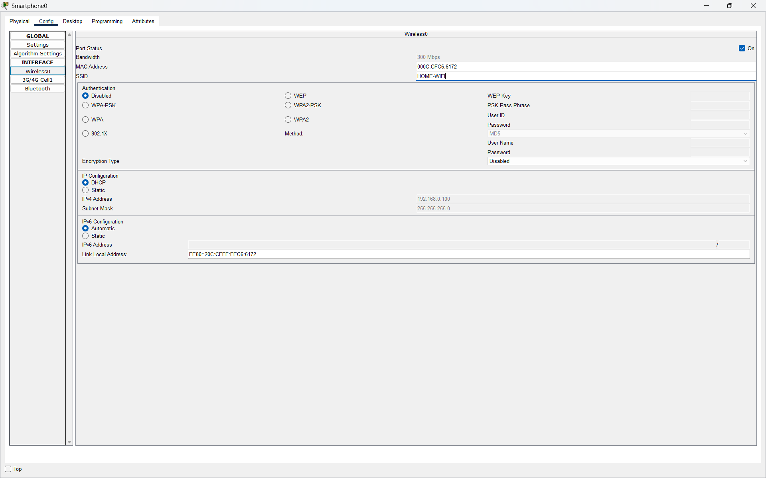

Q2. Change your Wi-Fi router's channel setting from 'Auto' to a manually selected channel (such as 1, 6, or 11), then use a Wi-Fi analyzer app on your phone to check if your new channel has less interference from nearby networks.<br><br><em><strong>Hint:</strong> Look for overlapping channels and pick one with the least overlap.</em>?

Answer
- I opened the wireless router settings in Cisco Packet Tracer.
- I changed the wireless channel manually from Channel 1 (2.412 GHz) to Channel 6 (2.437 GHz).
- I verified that Laptop0 was still connected to the wireless router.
- The signal strength and link quality were good.
- Result: The wireless channel was successfully changed to Channel 6. Actual interference comparison was not available in Cisco Packet Tracer.
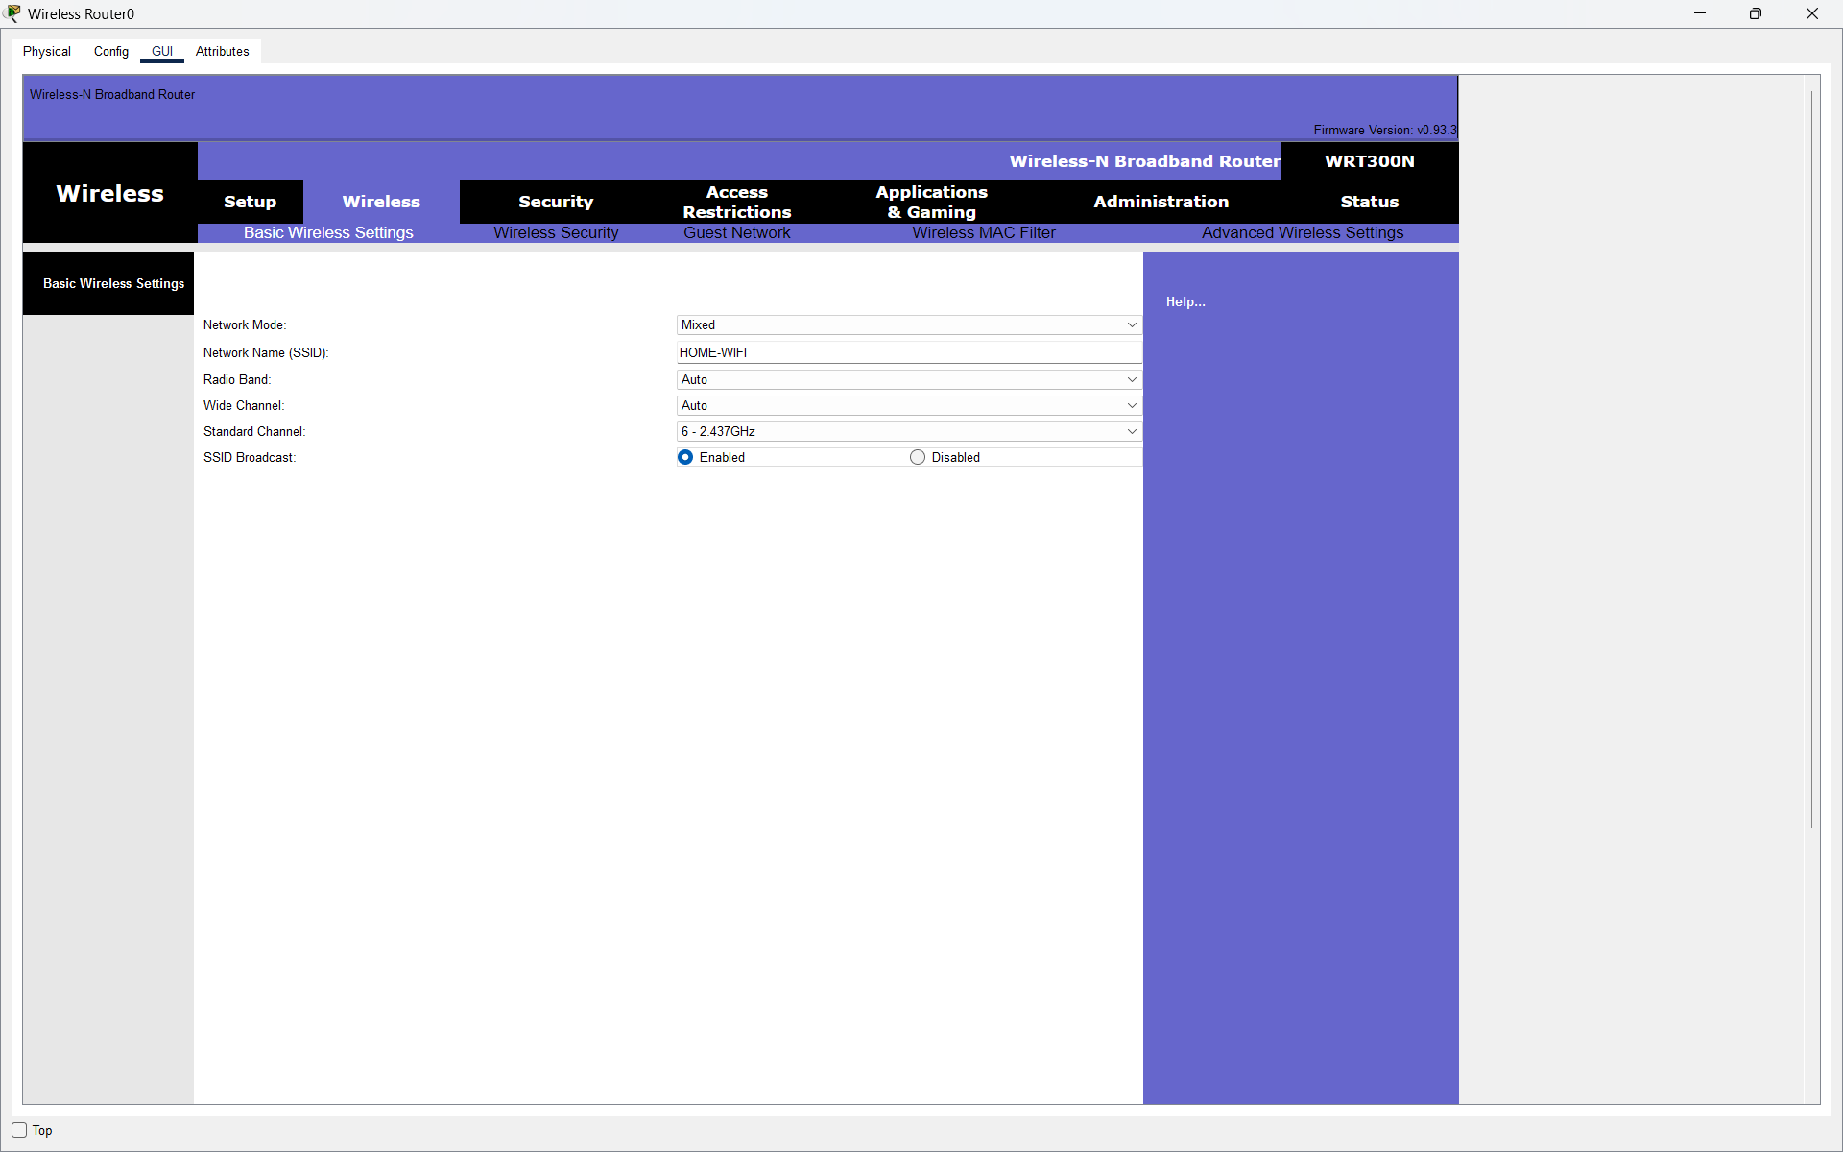
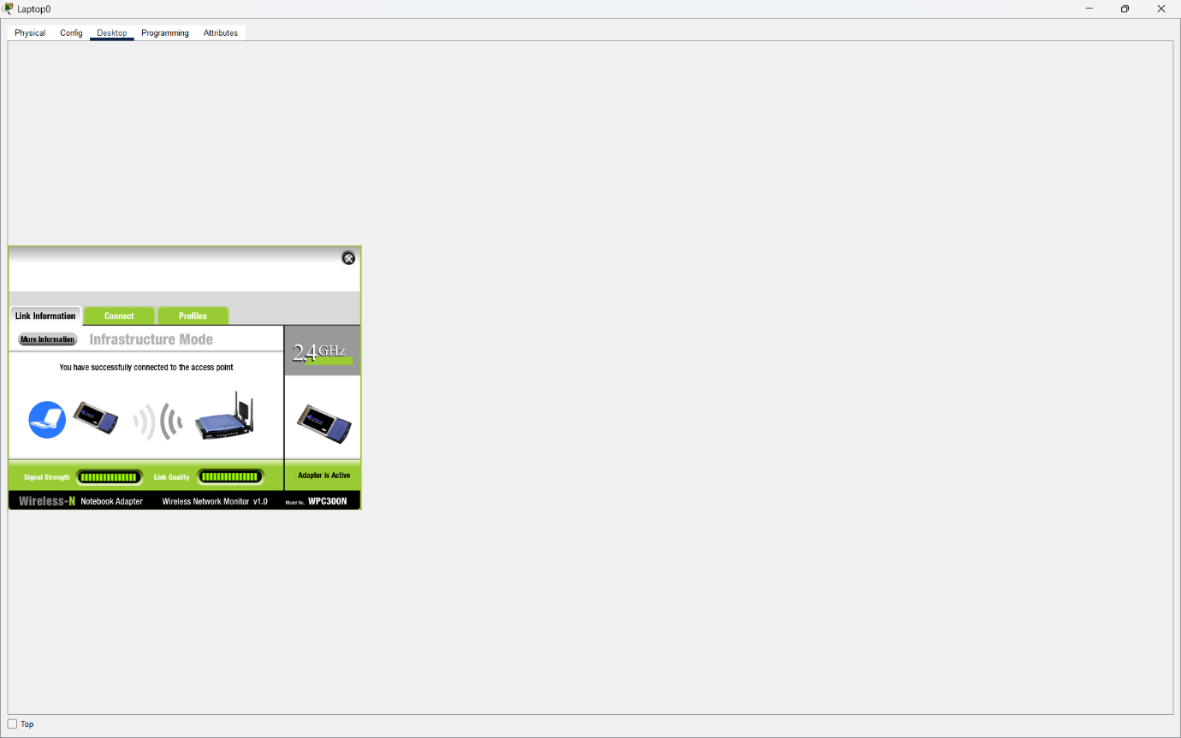

Q3. Enable WPA2 or WPA3 security on your wireless router, set a strong password, and attempt to connect a device using the new credentials to verify the security setting is active?

Answer
- I configured WPA2-Personal security on the WRT300N wireless router.
- I selected AES encryption and set a strong Wi-Fi password.
- I configured Laptop0 and Smartphone0 with WPA2-PSK authentication.
- I successfully connected Laptop0 using the new Wi-Fi password.
- Result: WPA2 security was enabled successfully, and the wireless network is password-protected.
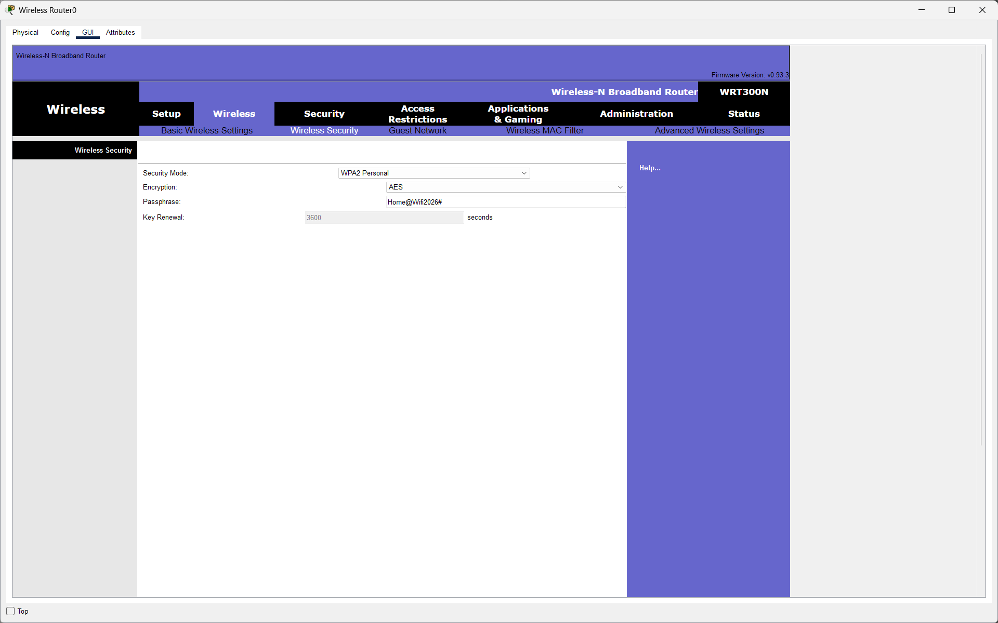
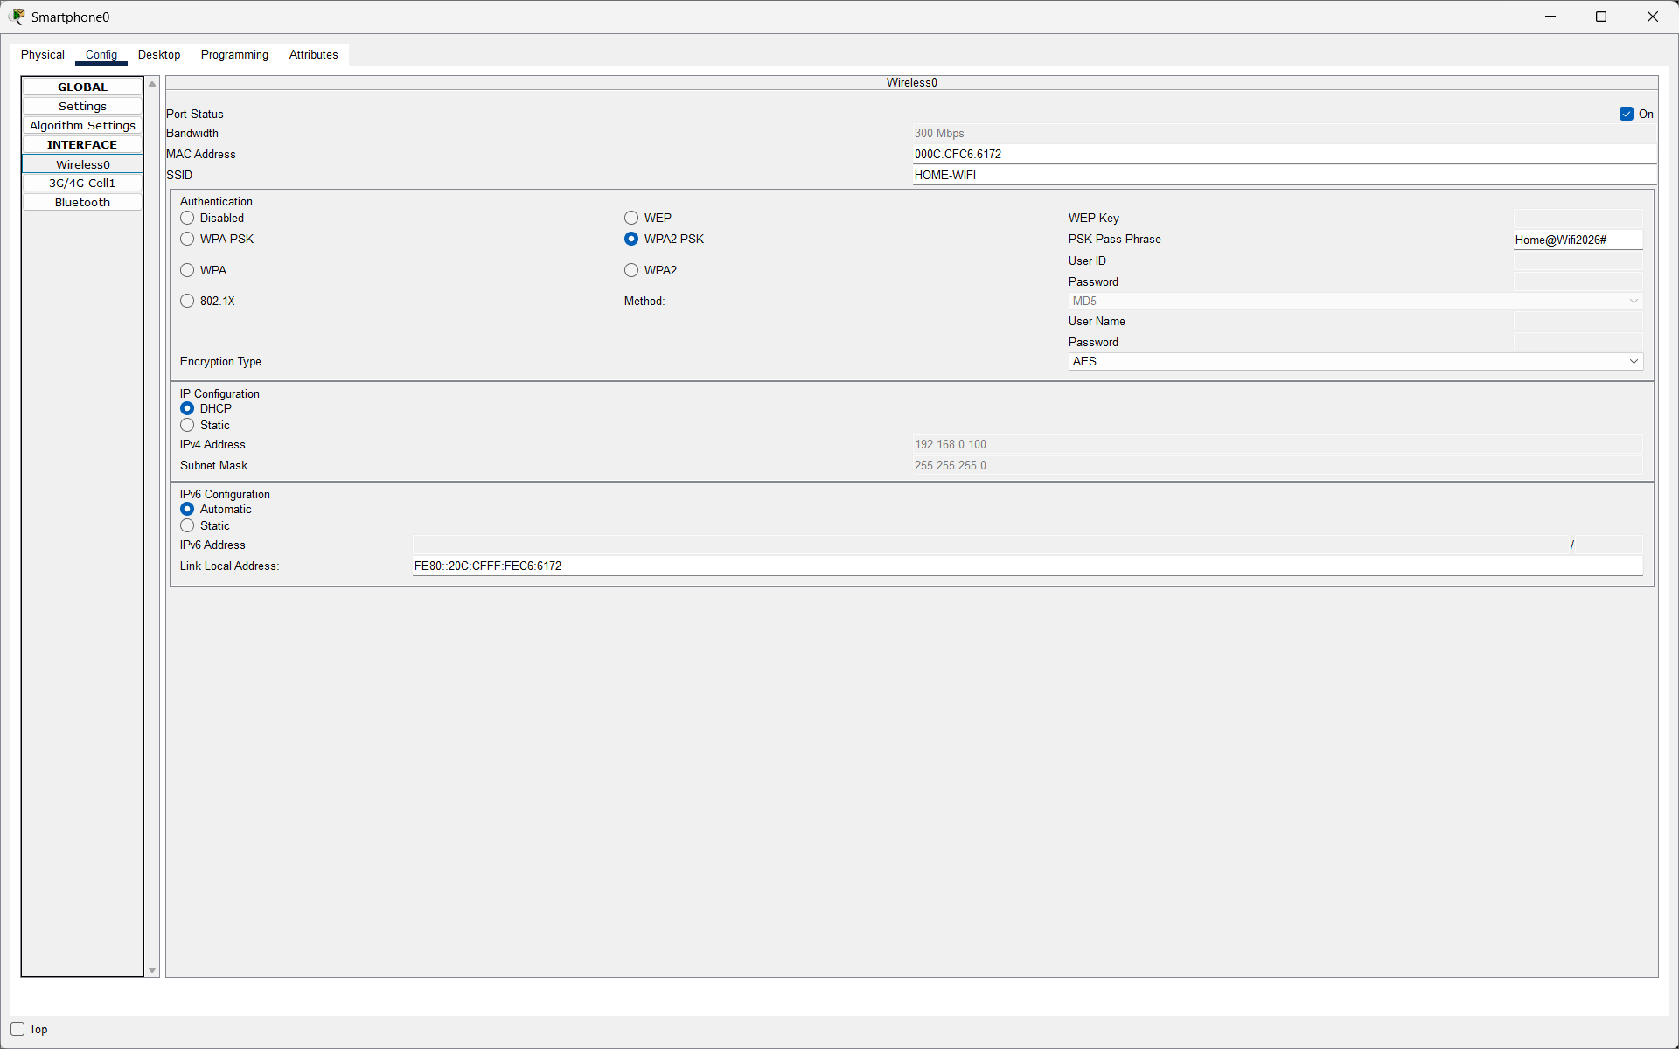
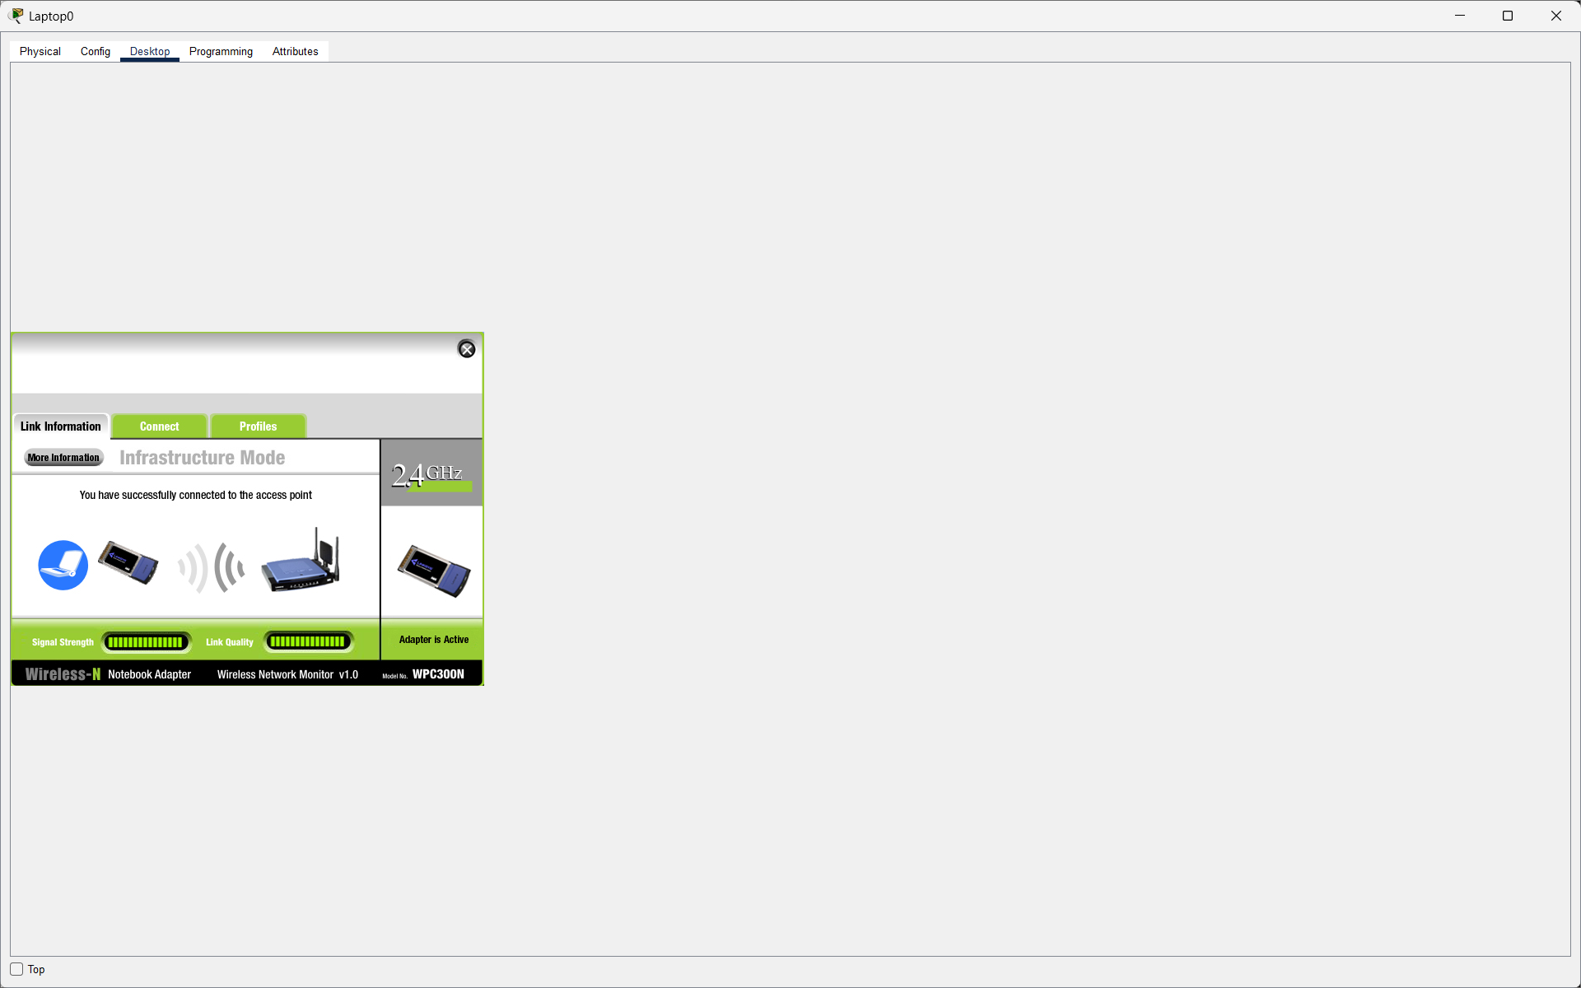

Q4. Configure MAC filtering on your Wi-Fi router by adding your device's MAC address to the allowed list, then try connecting with another device not on the list and observe the result.<br><br><em><strong>Hint:</strong> You can find your device's MAC address in the network settings.</em>?

Answer
- I enabled MAC Address Filtering on the WRT300N wireless router.
- I selected the option to permit only devices listed in the MAC filter.
- I added Laptop0's MAC address 00:02:4A:AC:BD:D0 to the allowed list.
- I tested Smartphone0, which was not included in the allowed list.
- Smartphone0 was unable to connect to the wireless network.
- Result: MAC Address Filtering was successfully configured, and unauthorized devices were blocked.
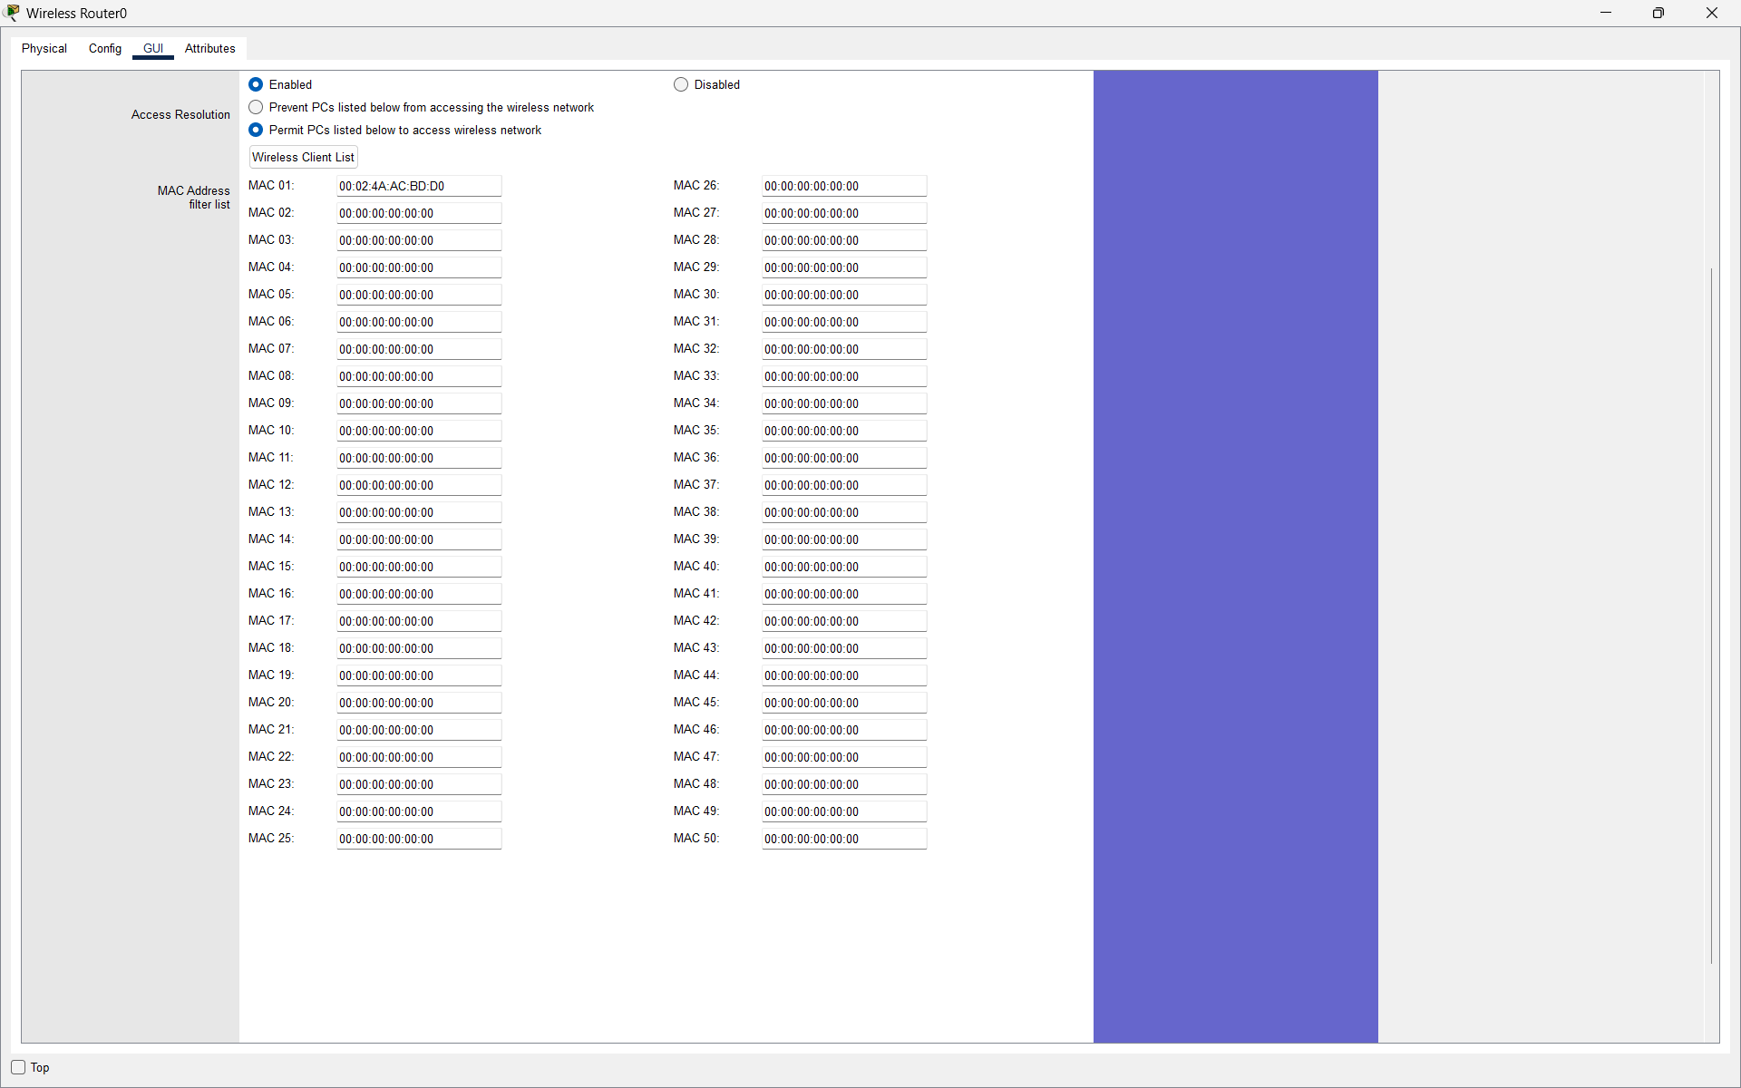
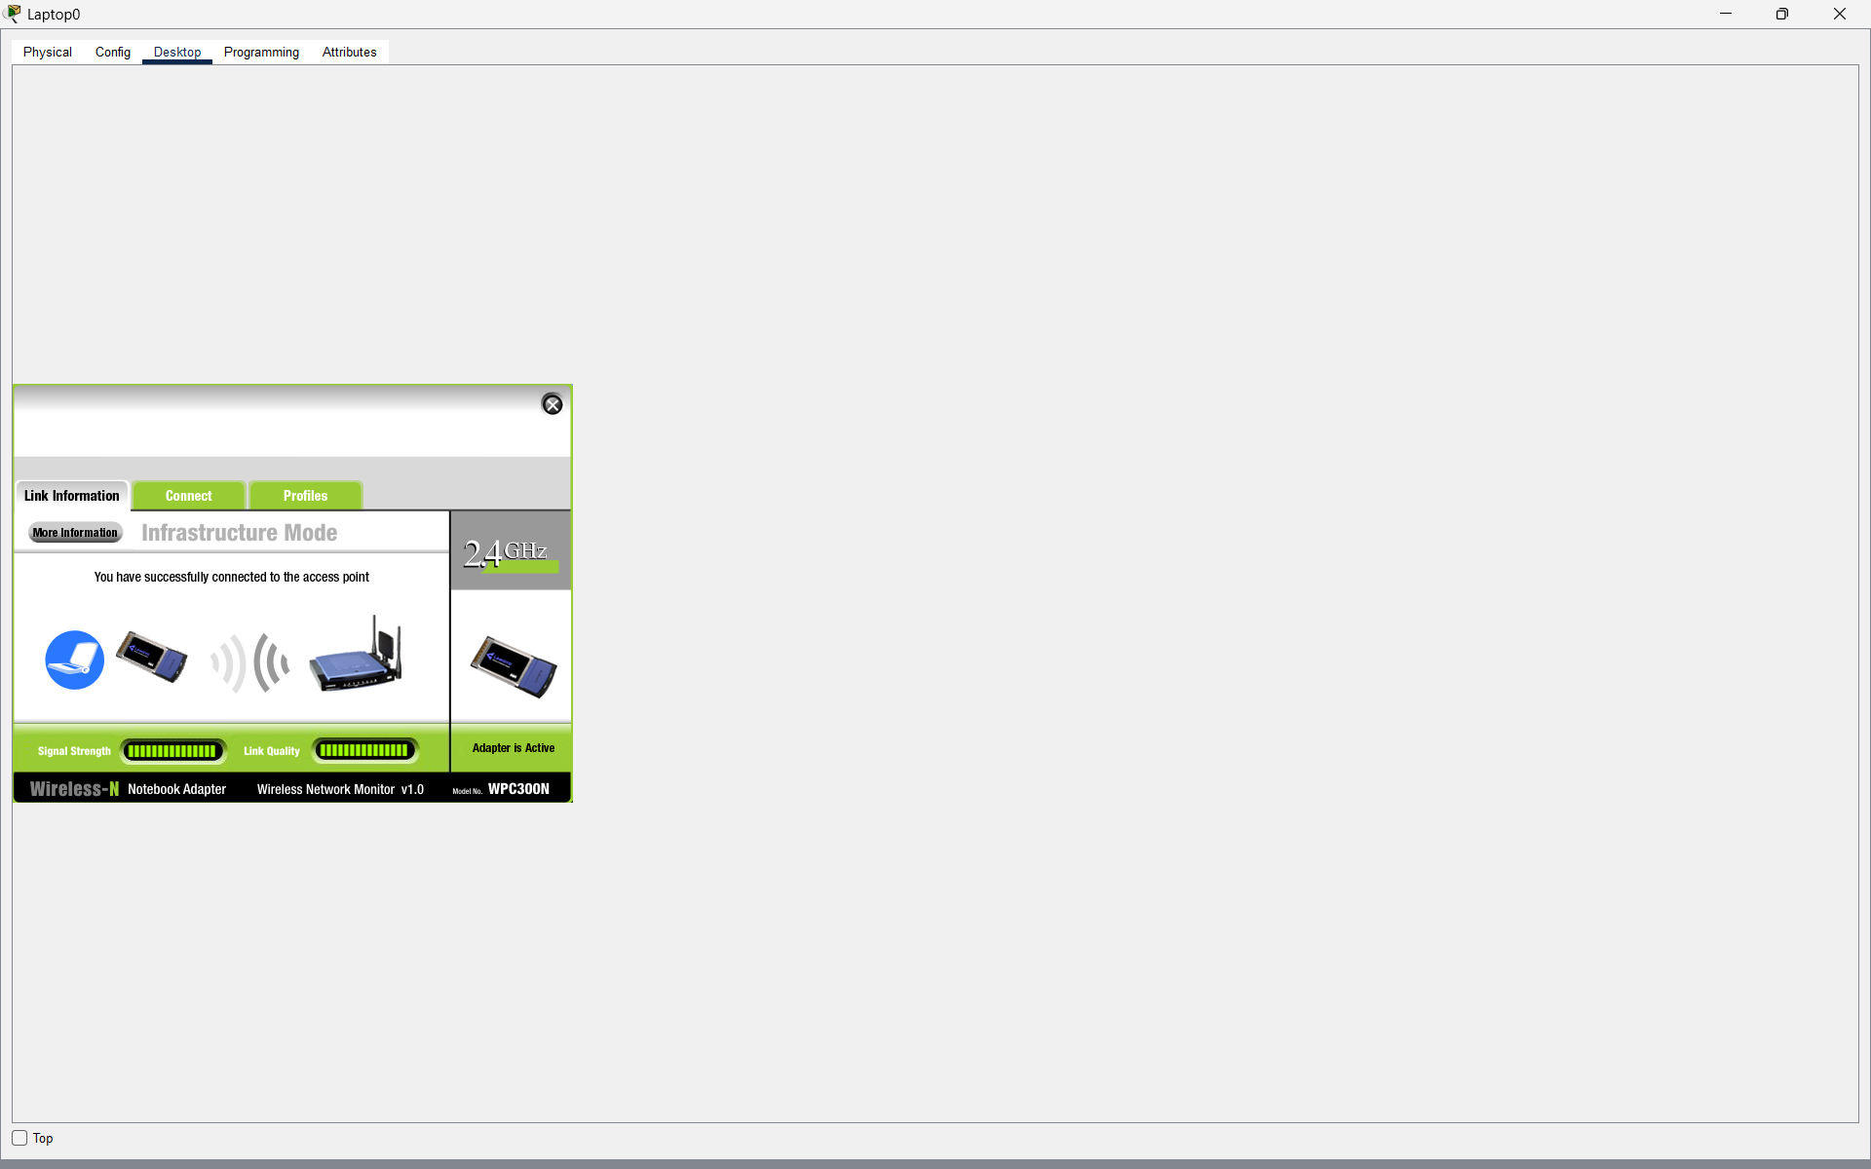
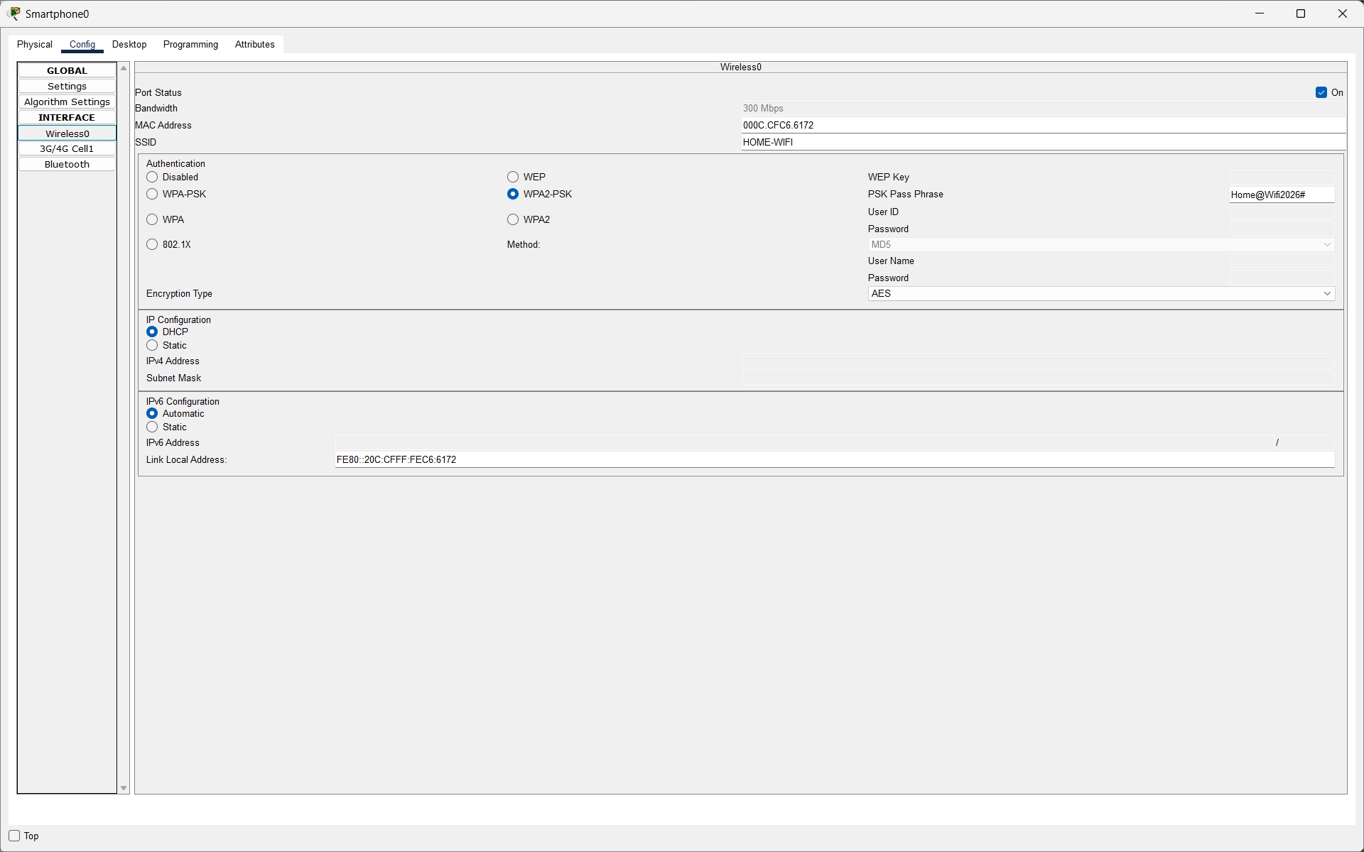

Q5. Create an Access Control List (ACL) on your router to block access to a specific website (for example, www.youtube.com) from your Wi-Fi network, and test if the block is working by trying to access the site from a connected device?

Answer
- I opened the Access Restrictions settings on the WRT300N wireless router.
- I created a policy named Block-Youtube and enabled it.
- I added Laptop0's IP address 192.168.0.101 to the applied PCs list.
- I entered www.youtube.com in the Website Blocking section.
- I tested the website using Laptop0's web browser, and the website was not accessible.
- Result: The website-blocking policy was configured successfully. However, the block could not be fully verified because Cisco Packet Tracer does not provide real internet access.
